Teddy Bear Cupcake Course
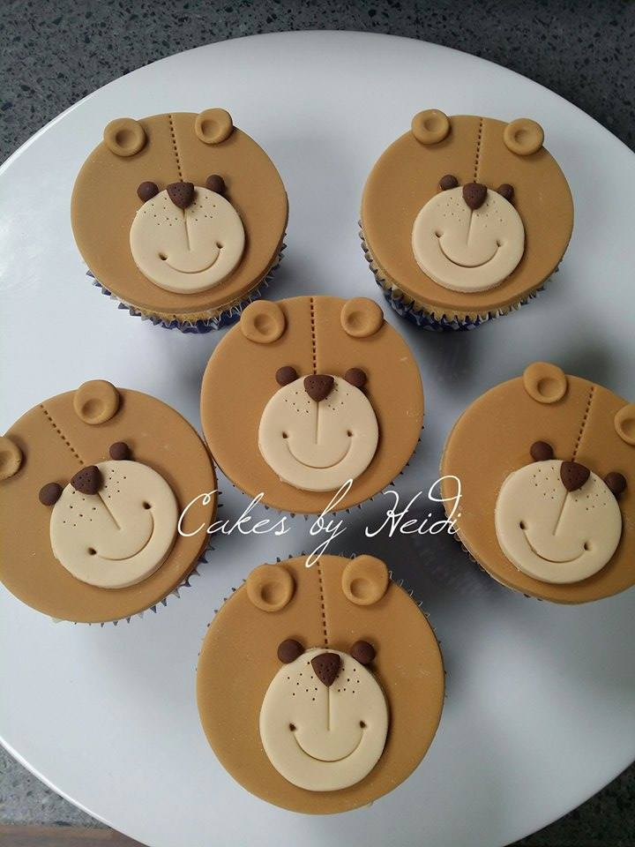

Saturday 30th May 2pm
Learn to decorate six Cupcakes
Go home with six lovely cupcakes
Course by Heidi
Fully inclusive of materials and equipment
Children over 6 welcome
£25

